**CTF Challenge: IoT and OT Hacking**



**IoT Hacking?**

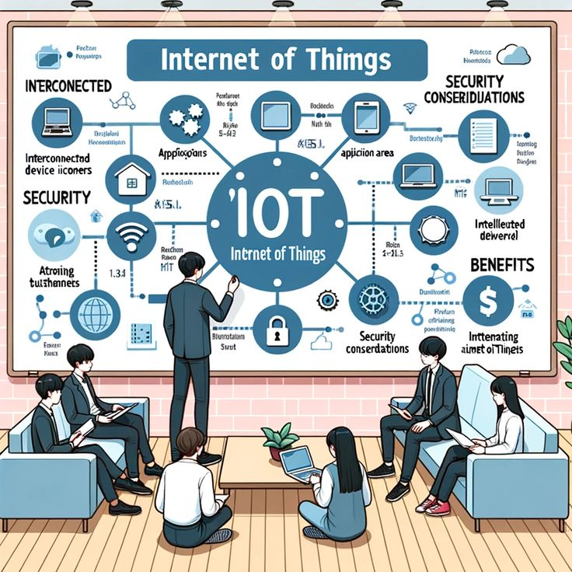

Involves exploiting vulnerabilities in internet-connected devices. These devices can range from household gadgets (smart thermostats, cameras, home assistants) to industrial equipment.

#### **Common Attack Vectors:**

1. **Weak Authentication**: Many IoT devices use default or weak passwords, making them easy targets.
2. **Unpatched Firmware**: Manufacturers often neglect regular updates, leaving devices vulnerable.
3. **Insecure Communication**: Lack of encryption can allow attackers to intercept data.
4. **Inadequate Authorization**: Poorly implemented access controls can allow unauthorized access.
5. **Physical Attacks**: Physical access to a device can lead to tampering and exploitation.

### **OT Hacking?**

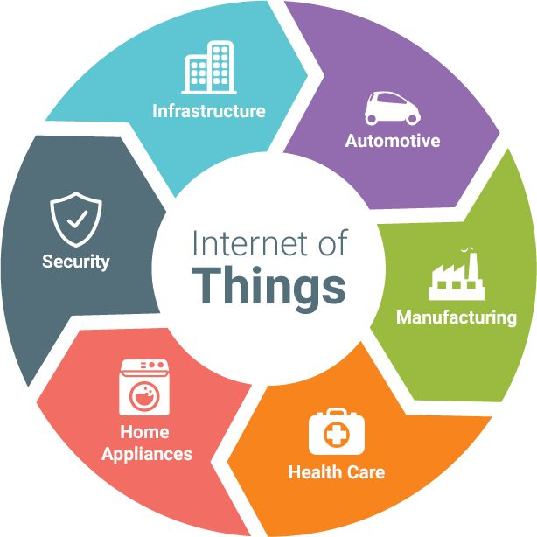

**OT Hacking** targets the hardware and software systems that monitor and control physical devices and processes in industrial environments.

#### **Common Attack Vectors:**

1. **Legacy Systems**: Many OT systems are old and not designed with modern security in mind.
2. **Network Segmentation**: Poor segmentation can allow attacks to move from IT to OT networks.
3. **Insider Threats**: Employees or contractors with access to OT systems can pose significant risks.
4. **Remote Access**: Unauthorized remote access tools can be exploited.
5. **Supply Chain Attacks**: Compromises in the supply chain can introduce vulnerabilities

# **Capture the Flag (CTF) Challenges**

**Flag 1. What is a common initial point of failure in IoT devices?**

Answer: Passwords

**Flag 2. Which type of network is crucial to segment from IT networks for better security in OT environments?**

Answer: OT

**Flag 3. What malware targeted Iranian nuclear facilities in 2010?**

Answer: Stuxnet

**Flag 4. What is a primary method for securing data in transit?**

Answer: Encryption

**Flag 5. What kind of attack can compromised IoT devices participate in, exemplified by the Mirai botnet?**

Answer: DDoS